Sunrise Beach Village

Leigh Thomas, PE HR Green

Water Distribution System Improvements

Phase 1: Mapping, Modeling and Planning

- Phase 1 Focus:
Project Focus and Goals
  - Developing Map of Water System
  - Modeling Existing Water System
  - Evaluating Future Water System Demands
  - Developing a Prioritized Plan for Water System Improvements

Phase 1 Goals:
  - Water System Map Data (ArcGIS) for Current & Future Applications
  - Modeled Simulation of Water System Operations
  - Identification and Prioritization of Water System Needs
  - Phased Plan for Design & Construction of Water System Needs

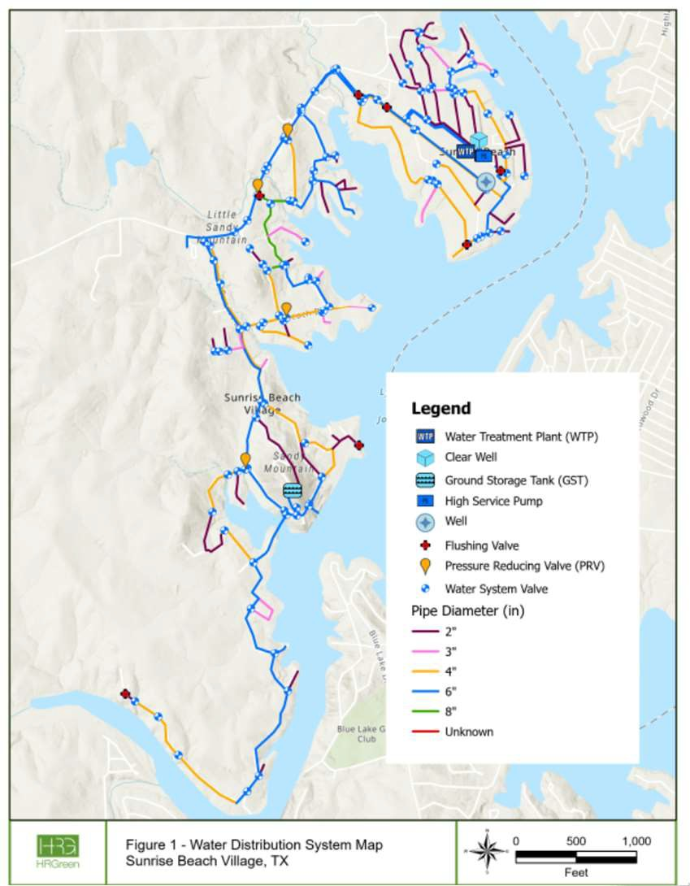
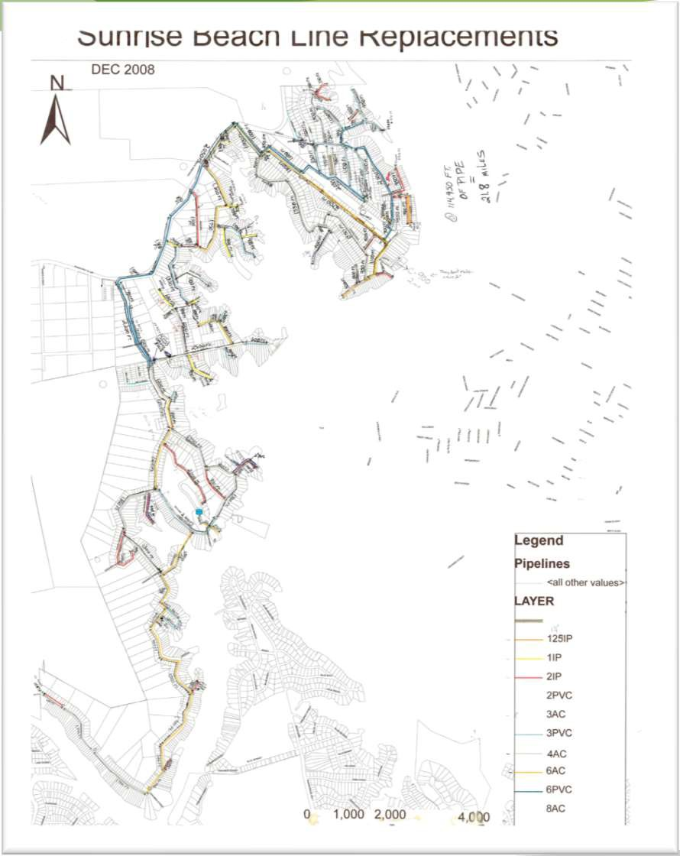
Mapping Process

Scanned in Map
Electronic Map

Existing System Characteristics

System Component | Characteristics | Size & Capacity
Water Transmission and Distribution Pipe | 2-inch pipe | 25,936.3 LF
 | 3-inch pipe | 8,130 LF
 | 4-inch pipe | 31,869.7 LF
 | 6-inch pipe | 41,174.8 LF
 | 8-inch pipe | 2,708.6 LF
 | Unknown pipe size | 27.4 LF
 | Total Pipe Length | 109,846.8 LF
Water Transmission and  Distribution Pressure Maintenance | Four (4) Pressure Reducing Valves | Three (3) 4” diameter
 |  | One (1) 6” diameter
Storage Capacity | One (1) 113,358 gallons GST | - Diameter: 32 feet (ft)  - Height: 18 ft  - Operating Range: 16.5 ft – 13 ft (high service pump on level)  - Overflow Level: 17 ft
 | One (1) 19,000 gallons Clear Well | - Diameter: 14 ft  - Height: 17 ft  - Overflow Level: 16.5 ft
Well Production Capacity | Two (2) Operating Groundwater Wells | Well 4b: 250 – 300 gpm²
 |  | Well 4c: 380 gpm (max)
Pumping Capacity | Three (3) High Service Pumps³ | High Service Pump 1: 250 gpm
 |  | High Service Pump 2: 280 gpm
 |  | High Service Pump 3: 260-270 gpm

Modeling Process

Water System Operations Simulation
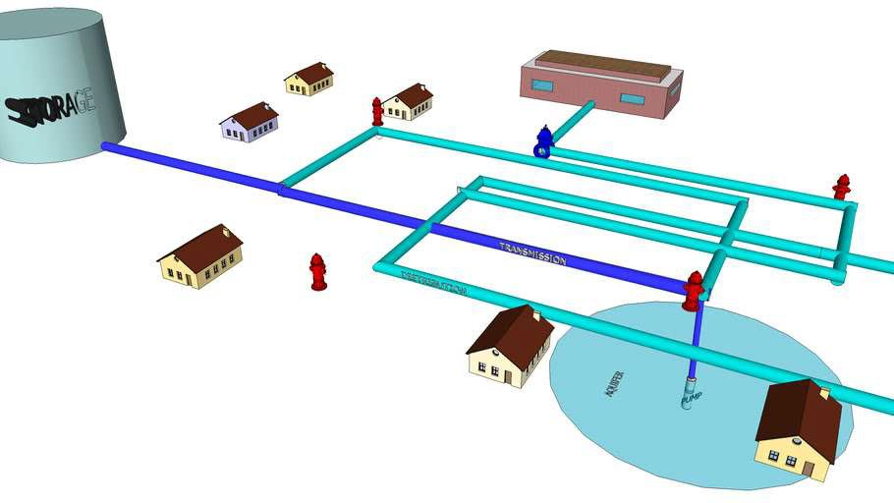
Steady State Model Simulation
- Three High Service Pumps modeled as source
supply from clear well to GST.
- Hydraulic calculations to determine system flows and resultant system pressures.
- No operating system pumps in static model.
- Operating range of GST and HGL (Hydraulic Grade Line) of 1,054 ft (low operating point)
- PRVs disabled to avoid impact on model pressure results

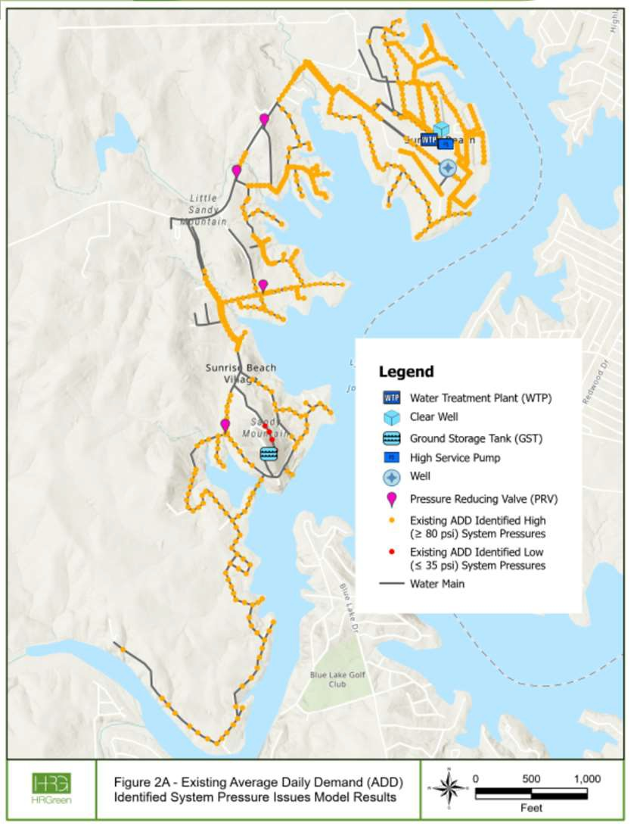
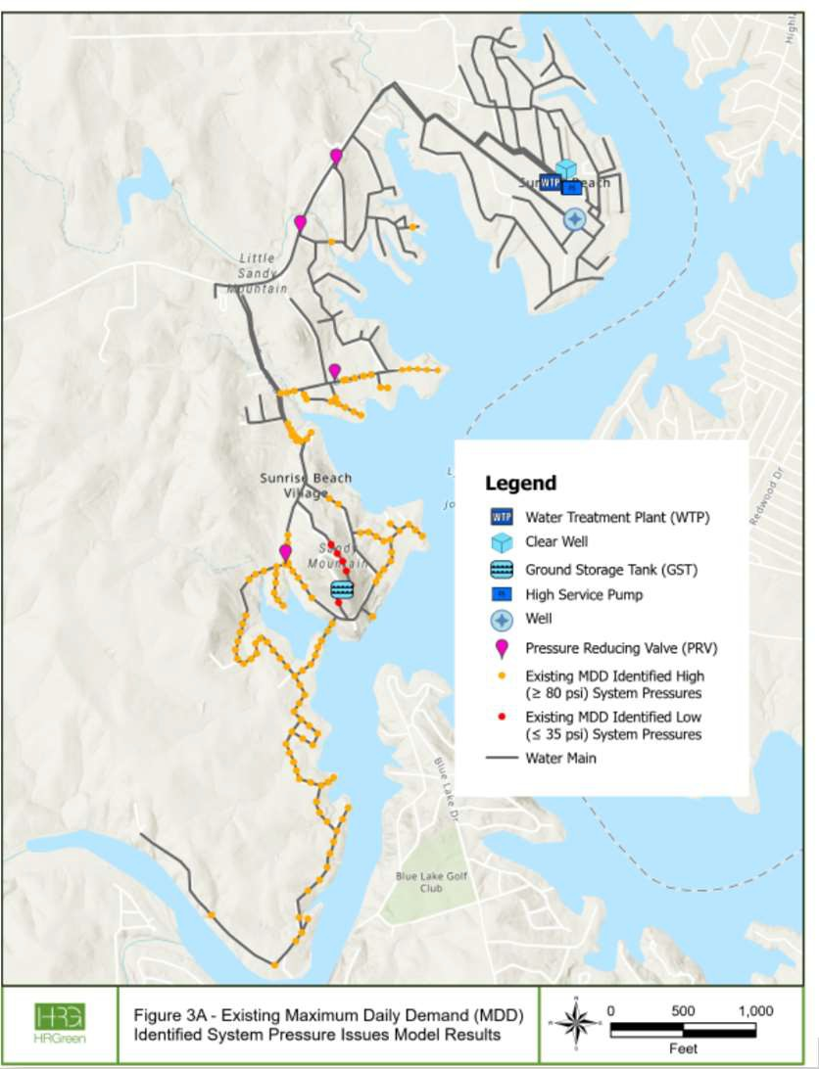
Modeled Scenarios – Current

Average Daily Demand
Max Daily Demand

1,030
System Connections Applied

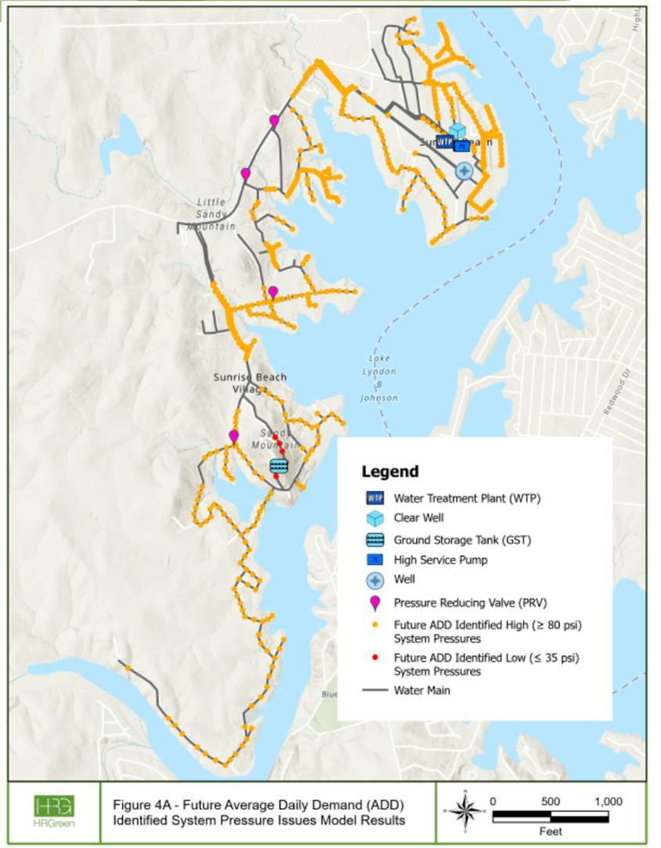
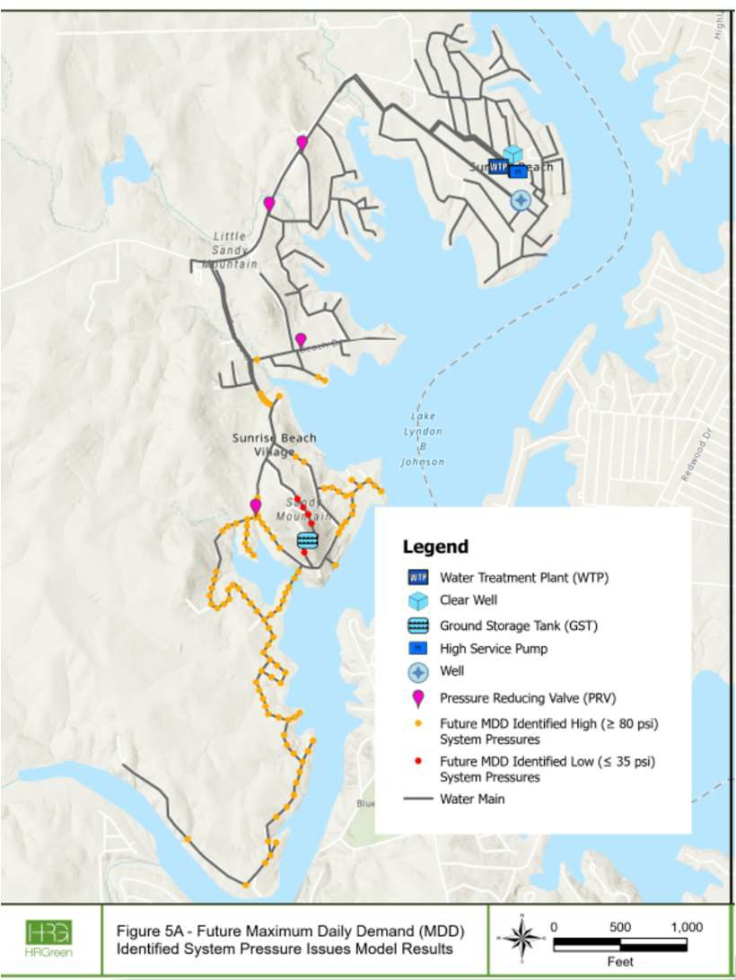
Modeled Scenarios – Future

Max Daily Demand
Average Daily Demand

1,200
System Connections Applied

WATER SYSTEM CAPACITY PER CONNECTION BASED ON 30 TAC §290.45(B)(1)(D)
TCEQ Requirements

TCEQ Minimum Existing System Projected 2034 System System Parameters System Capacity (1,030 Capacity (1,200 connections)
Requirements¹ connections) with Existing System
Water Supply | 0.60 gpm/conn | 0.66 gpm/conn² | 0.57 gpm/conn²
Storage Capacity | 200 gal/conn | 129 gal/conn³ | 110 gal/conn³
Pumping Capacity | 2.00 gpm/conn | 0.78 gpm/conn⁴ | 0.67 gpm/conn⁴
Pressure Maintenance | 100 gal/con | 110 gal/conn⁵ | 94.5 gal/conn⁵

EXISTING SYSTEM DEMAND AND STORAGE VS. 30 TAC §290.45(B)(1)(D)
TCEQ Requirements
System Parameters | TCEQ Minimum System Requirements | Existing (2023) System Capacity | Existing System Difference¹
Average Daily Demand | N/A | 192,412 gpd² | N/A
Maximum Daily Demand | N/A | 393,916 gpd² | N/A
Water Supply (Well 4b + 4c) | 618 gpm | 680 gpm³ | +62 gpm
Storage Capacity (GST + Clear Well) | 206,000 gal | 132,358 gal | (73,642 gal)
Pumping Capacity | 2,060 gpm | 800 gpm⁴ | (1,260 gpm)
Pressure Maintenance (GST) | 103,000 | 113,358 gal⁵ | +10,358 gal
PROJECTED 2034 SYSTEM DEMAND AND STORAGE VS. 30 TAC §290.45(B)(1)(D)
Parameters | TCEQ Minimum Requirement | 2034 Projected System Capacity¹ | 2034 System Projected Difference¹
Average Daily Demand | N/A | 224,169 gpd² | N/A
Maximum Daily Demand | N/A | 458,931 gpd² | N/A
Water Supply (Well 4b + 4c) | 720 gpm | 680 gpm³ | (40 gpm)
Storage Capacity (GST + Clear Well) | 240,000 gal | 132,358 gal | (107,642 gal)
Pumping Capacity | 2,400 gpm | 800 gpm⁴ | (1,600 gpm)
Pressure Maintenance (GST) | 120,000 | 113,358 gal⁵ | (6,642 gal)

Recommended Improvements
Priority 1 Water System Improvements Summary

Category | Improvements Description | Quantity | Unit
P | Pipeline improvements for pressure deficiencies¹ | 22,991.80 | feet
SD | Small diameter pipeline replacement for pipelines with a diameter 4 - inches and smaller² | 5,737.90 | feet
S | Storage Improvements | 75,000 – 110,000³ | gal
PC | Pumping Capacity Improvements | 1,260 – 1,600³ | gpm
Priority 2 Water System Improvements Summary
Category Improvements Description Quantity Unit
P | Pipeline improvements for pressure deficiencies¹ | 90,928.80 | feet
SD | Small diameter pipeline replacement for pipelines with a diameter 4 - inches and smaller² | 28,355.70 | feet
PC | Pumping Capacity Improvements³ | TBD | gpm
Priority 3 Water System Improvements Summary
Category Improvements Description Quantity Unit
P | Pipeline improvements for system resiliency¹ | 15,828.90 | feet
S | Storage Improvements | 35,000² | gal
PC | Pumping Capacity Improvements | 340³ | gpm
WP | Water Production Capacity | 40⁴ | gpm
PM | Pressure Maintenance Capacity | 17,000⁵ | gal

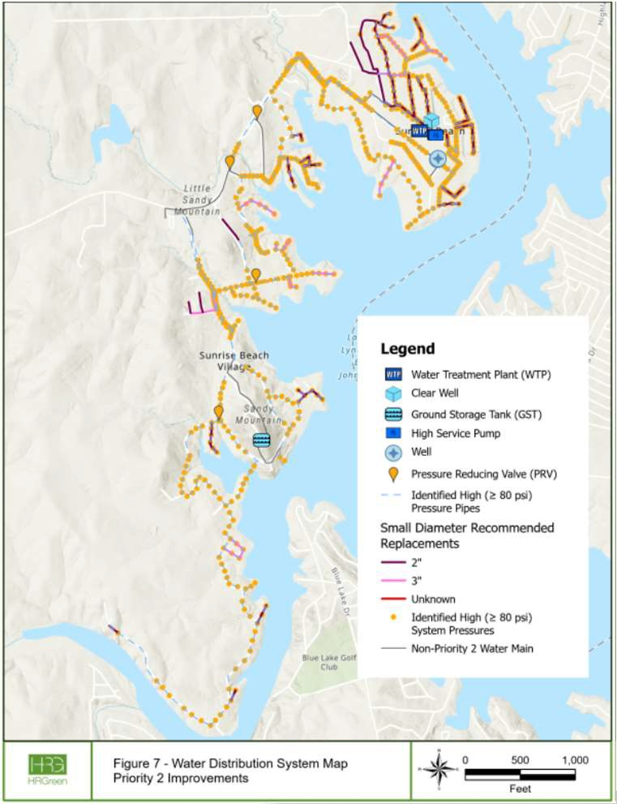
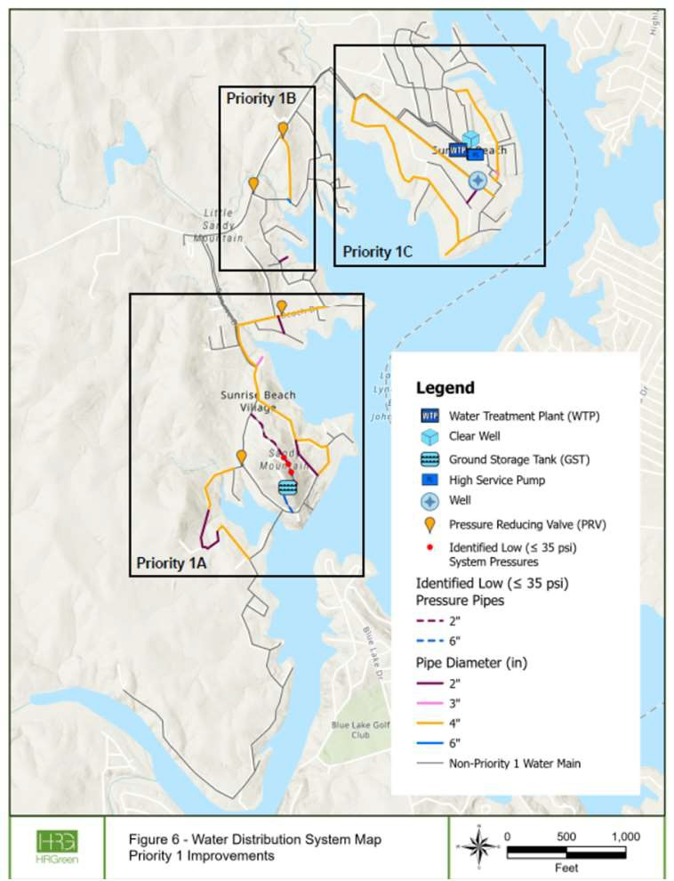
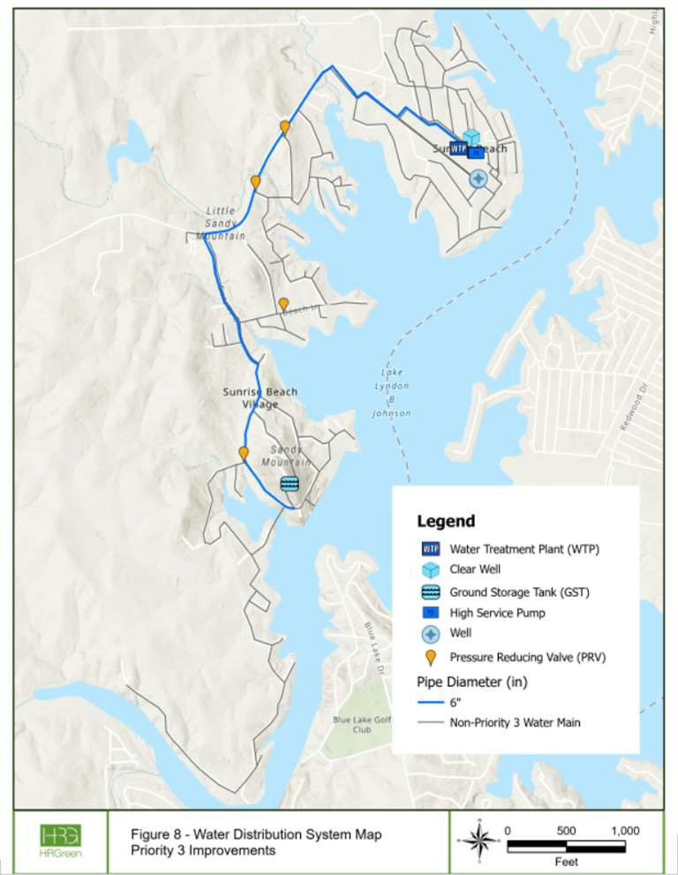
Recommended Improvements
Priority 1A, 1B, 1C
Priority 2
Priority 3

Priority 1A
Next Steps
Priority 1B
Priority 1C

Design ‘24 to ‘26

Design ‘26 to ‘27

Design ‘27 to ‘28

Construction ’25 - ‘28

Construction ‘27 to ‘28
Achieve TCEQ
Compliance

Construction ‘28 to ‘30

Future Steps

Priority 2
Design ‘31 to ‘33
Construction ’32 - ‘36
Meet Current Max Demand
Priority 3
Design ‘’36 to ‘38
Construction ‘37 to ‘40
Meet Future Demand

Discussion

Thank You!

Leigh Thomas, P.E. Regional Manager - Water HR Green, Inc.

